Khoa Tran

EE 271

July 25, 2020

Lab 4 Milestone

**Task #1**

Block Diagram of System:

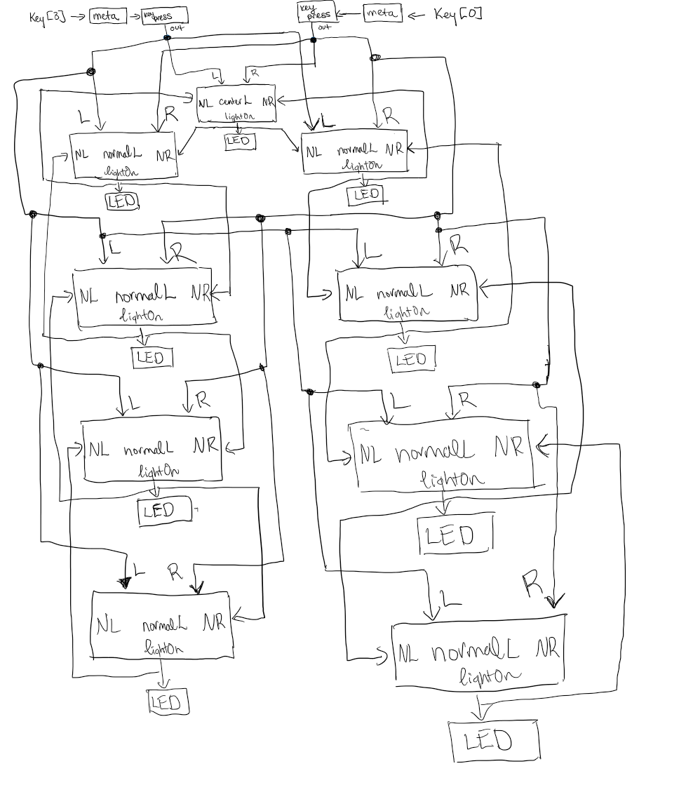

**Task #2**

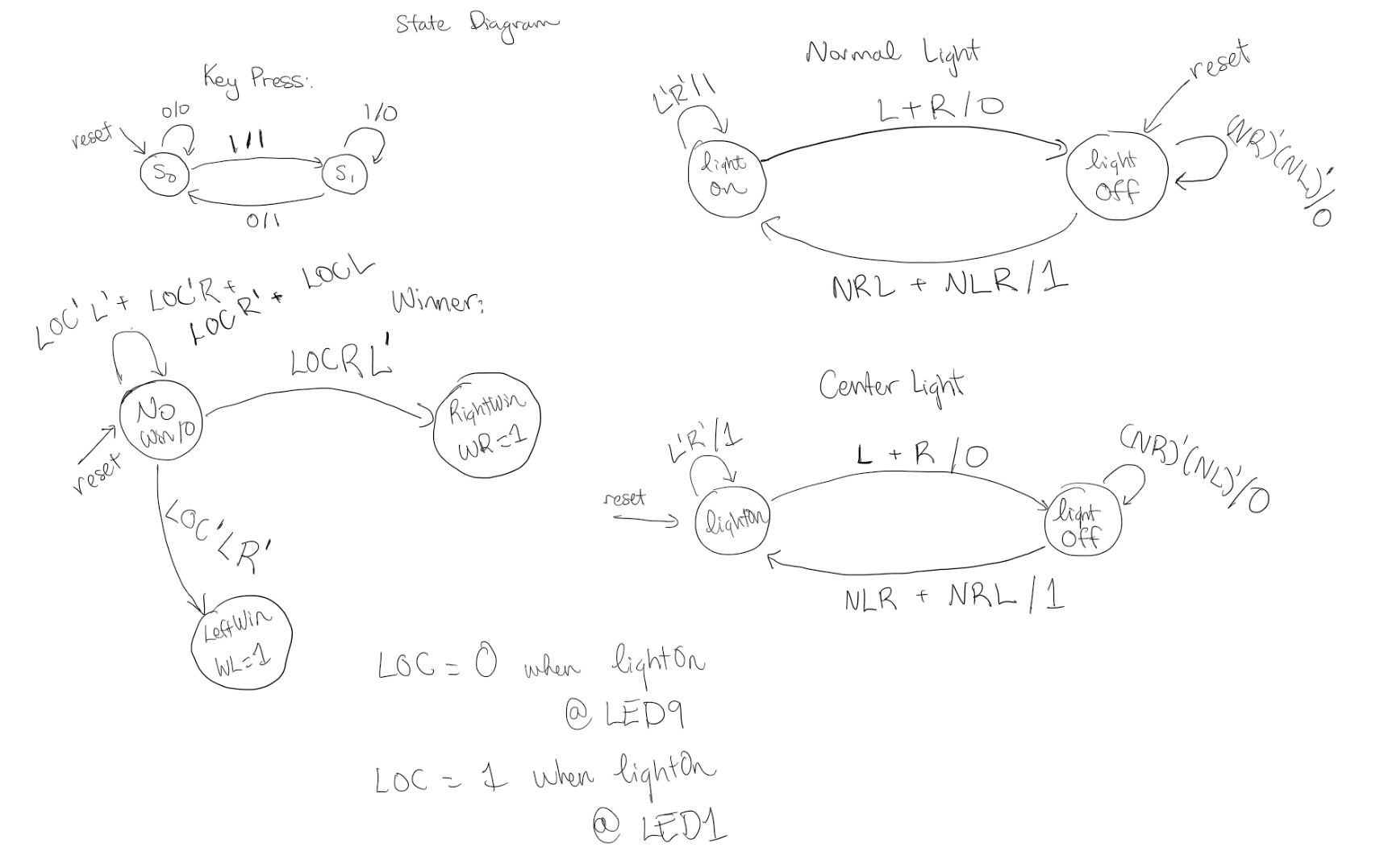State diagram for all FSM:

**Task #3**

Meta module

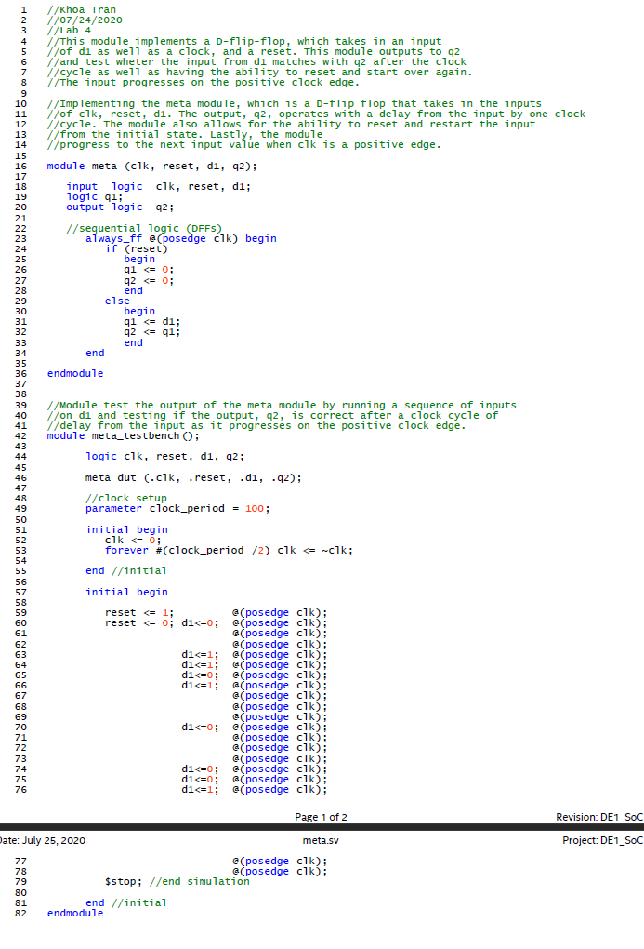

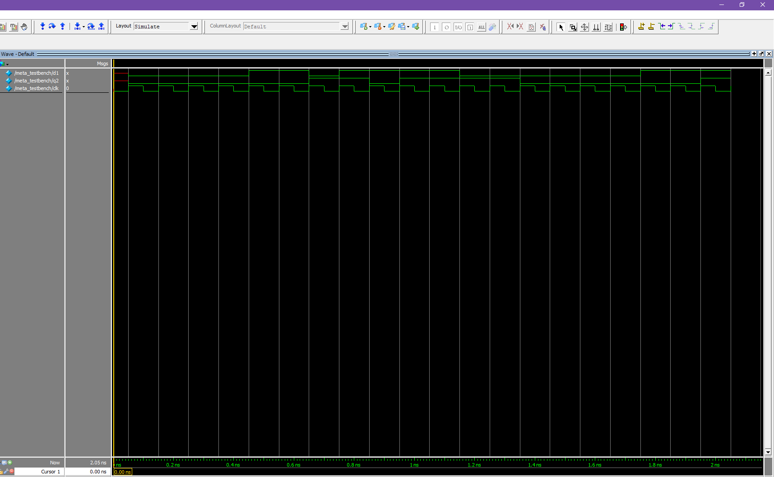Meta modelsim

Keypress Module

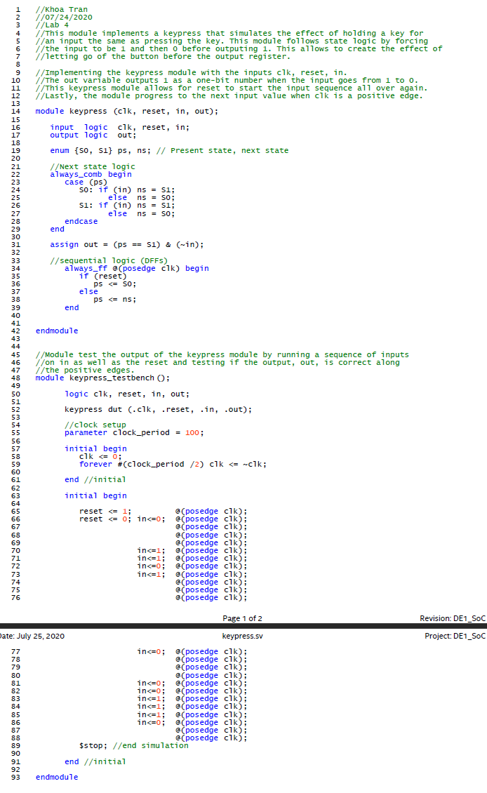

Keypress modelsim

